# 

# Magic Cards

*Ideal for Face-to-Face  
Any group size*

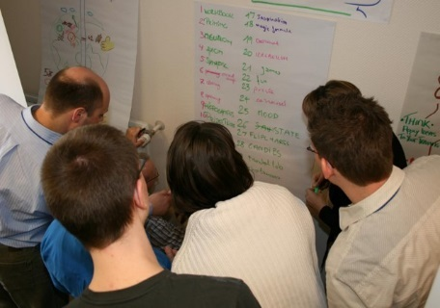

Use this review towards the end of a workshop when there has been enough content to generate 15 to 31 ideas/words from the workshop.

## Preparation

* Print and cut out the cards from the magic card’s handout (on your webpage or click the link at the bottom of this activity).
* Place enough flip chart sheets of paper around the room for the number of teams you will form.

## How To Facilitate The Magic Cards Review (31 items in the example below)

* Form teams of 4-6 learners.
* Ask each person to have a pen – ideally a flip chart pen each.
* Ask teams to make their way to a flip chart in the room.
* Ask the person that has been with the organisation for the longest time to put the numbers 1-16 down the left-hand side of the flip chart filling the entire length of the flipchart sheet from top to bottom.
* Ask the person that has been with the organisation for the shortest time to put the numbers 17-31 down the middle of the flip chart filling the entire length of the flip chart sheet from top to bottom.
* Announce that there will be a little inter-team competition. The winning team will be the first team to add 31 different things about the training so far, big or small. BUT no duplicates allowed. if you shout to say that you have finished and I see a duplicate you will have to sort that out allowing other teams to finish before you.
* Say “GO”.
* When the first team has finished, check for duplicates. If there are none, then they are the winners. Ask the remaining teams to complete their 31 ideas.
* Say, *”I’m going to try and read your minds. I’d like each team to select from their flip chart the key idea for them, BUT not to let me know and without marking their choice in any way. I’m going to leave the room for around 45 seconds so that you can make your choice.”*
* Leave the room and close the door. Wait about 1-minute then know before entering to check if they have made their selections. If not, go back out for another minute.
* As you enter, pick up the magic cards you need ie for 31 I’d need cards A-E.
* Go to either a ‘loosing’ team or the ‘winning’ team (you can play with this. With 2 teams I usually say I’ll start with the loosing team, I mean the team that came a close second).
* Place the cards on a nearby table.
* Say, *“The choice you made has a number next to it. I’d like you to slide to the left any cards that contains that number.”*Note – if you lay the cards vertically A, B, C etc then the next part is easy.
* As learners *slowly* slide the cards to the left add up the first number on each card they slide to the left. This is easy if you have the cards A, B, C as the numbers are 1, 2, 4, 8 etc so you can have them added up before they’ve even finished sliding them across.
* Move to their list and ask them to concentrate on their choice.
* Make a big show of trying to read their minds and suggesting that not everyone is focusing upon the same thing. Say, “But I think your choice is [say the idea they wrote]. Is that correct. It should be 😊.
* Ask why that was key for them.
* Do the same with the other groups.

**Example**  
With the image below, if the cards that were moved were the ones on the left ie the first 2 cards, then the item that was selected was item 3 ie 1 plus 2.

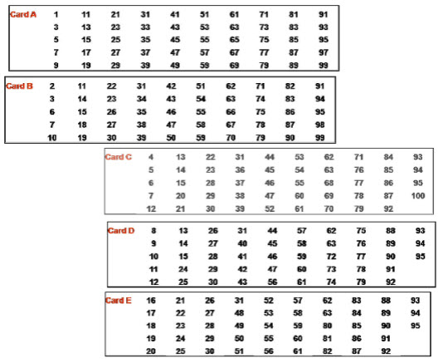

## ****Bands – the lowest number of cards for the highest review number****

* Cards A-D – Up to 15 review items
* Cards A -E – Up to 31 review items
* Cards A-F – Up to 63 review items
* Cards A-G – Up to 100 review items

If you forget the bands, simply put out all the cards and review any number of items up to 100.