## Accessible and Inclusive Design

# Is it possible to make documents *completely* accessible?

Accessibility Help in MS Office

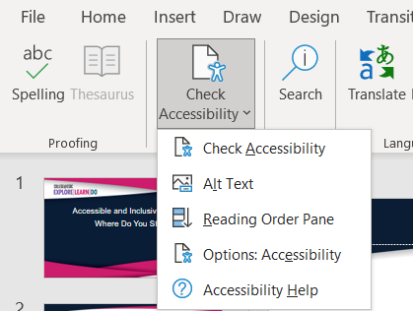

Assistive Technology

# Dolphin, JAWS, TalkBack, ZoomText, MAGic, Dolphin, Dragon Naturally Speaking, Keyboard, Windows Tools.

Word Tips

PowerPoint Tips ...

# Images and Alt Text

Decorative

Short description

Long description

# Tables

|  |  |  |
| --- | --- | --- |
| Tips for Tables | | |
|  |  |  |
|  |  |  |
|  |  |  |